Chapter 0

Before we do a dive into the mysteries of Kabbalah I will like to start talking about one of the most important tools, the tree of life. This was first found in kabbalistic writing back to first centuries of the last millennium, It is a map which everything in this known universe is defined and created from the universe itself to human beings, including relationships in between them and other creatures; you should be advised not to mistake the map with the territory as we look at a map of London and we don’t think the airport is just 5 meters away from the centre of the city.
The tree of life is formed by 10 shepirot, singular shepira, whose meaning or root comes from number in hebrew or saphira (which is a mineral which comes in 10 different colours); and 22 channels represented for the 22 letters of Hebrew also known as alephbet. This 10 shepirot are connected through the 22 channels as it is represented at ‘Figure 1’. Note: There are other representations of the tree of life with other channels, like the hermetic tree of life where the channel Chokma - Guevura is at Netzach - Malkuth and the channel Bina - Chesed is at Hod - Malkuth. Each sephira represents a different energy or vibration and the channels in between them too, we will explain in detail both in following chapters. Here we will follow a small approach for each sephira.

As it was described before the tree of life it is a schema where everything is created from, in this brief introduction of the tree of life we are going to put the focus on one of the 5 Olamot (Hebrew for worlds we could define it as universes too, Olot in singular), Yetzirah also known as the universe of Formation. And to be more specific on the psychological part of it. It will be defined and explained in following chapters what are the Olamot and how they work.

For this intro to the tree of life we will be starting at the 10th sephira, Malkuth, as being closer to us because it represents where the energies constraint the most and becomes matter, as the world of matter is we will interact the most; and we will climbing the ladder following a Lightning bolt or flash known in Kabbalah as the Path of the serpent (it will be explained in future Chapters); in a countdown from 10th sephira to 1st sephira.

I would like to clarify first that every single sephira has the same relevance and they are graphically set above each other but does not mean that they are actually above in importance, the map is not the territory. Also it is important to remark that, even though we are explaining them separately in this introduction as a first approach, they are all working on us all the time at the same time, and even though some are less connected with us, there is always a connection to them and each channel.

A sephira has two main attribute represented in kabbalah as ‘ohr’ (hebrew for light, plural orot) and kli (hebrew for vessel, plural kelim), which can be understood as power and form, the ability to give and receive and others which we will see in future chapters. This energy that is coming to this sephira can be used or shared into others sephiras and depending how we use it they will be in 2 possible basic states with 3 different outcomes, this states are call middah (hebrew for measure or quality, plural middot) or equilibrium, balance state and kilppah (hebrew for shell or husk, plural Klippot) or disequilibrium, unbalance state. There is one point of balance where the energies are working in the natural way and the sephira
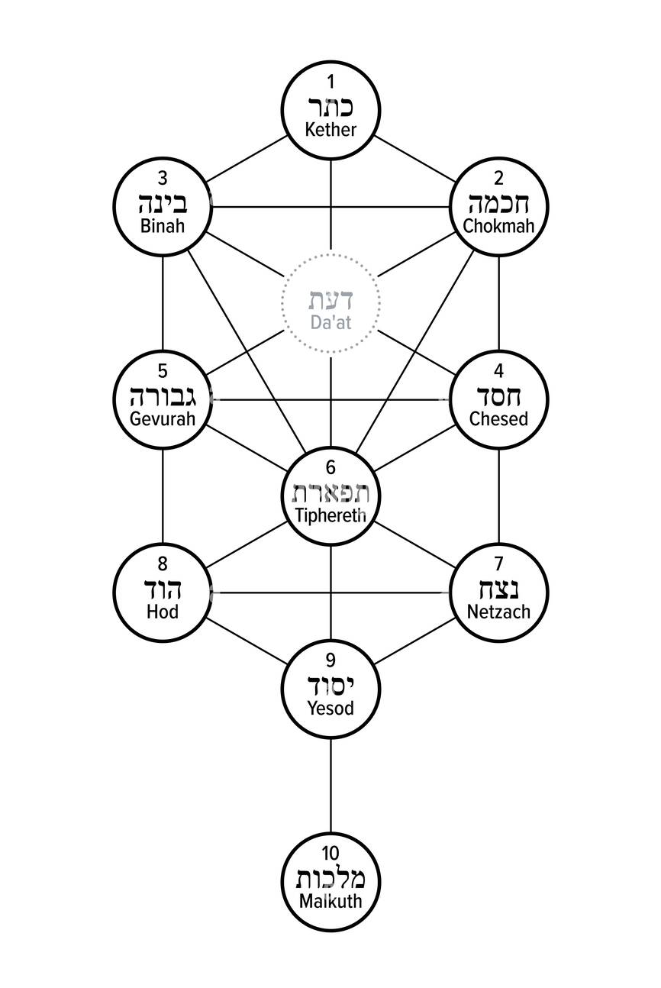
Figure 1:Tree of life with the 10 sephirot and the 22 channels, including the half-sephira Daat
is balanced and two points of unbalance, first one for lack of energy, we are expending too little of our energy on it; and second one for excess of energy, we are expending too much energy on it, for example caring too much for others and neglecting the care of ourselves.

Also we need to remark that the tree of life is a whole system, a whole environment where all the elements interact with each other and care about each other (even when we do not) so if an element of the system, sephira, is unbalance, the others members of the system will try to help it and balance the system by giving energy to the one asking for more energy or in the opposite way over working to compensate a lack of energy on other sephira. This way to balance the system will work for a bit but if we maintain this rhythm for a while other sehirot will unbalance and unbalance others, unbalancing the whole system.

In this brief of the tree of life we will be giving a short explanation of the energies of each sephira, how they work in this specific olot of yetzirah related with psychology, what are the basic klipoth and mida, usually one for each type of klippah and one middah. In the future we will explore more in depth each sephira and tools will be provided to work in the energies of each sephirah. So let's get started with our journey and start climbing the leader.

10th sephira - Malkuth - The kingdom

This sephira represents the energy of the matter, and here because we are talking about our psych, represents how we interact with the matter and how we perceive it; so which element of the matter would be more representative of them to all of us? What about money, for some god itself (like the one dollar note) and for others the root of evil.

Here without pretending we just define 2 sides of the coin for the basic klippoth; People could have klippah here by exceed of energy by using all their energy (like time) finding ways to accumulate more and more riches and making their propose just increasing it leading them to a world of stress and dissatisfaction showing themselves as representation of the amount of ‘money’ they have (the more we have the more value we have) and making the whole propose accumulate each and every day more.

In kabbalah there is not an issue with money although it is important the use we do of it, for example we could have lots of millions on use it to finding cures for current diseases and putting the discoveries affordable for all the population (like Jonas Salk who created the polio vaccine saving million of lives and losing an estimate of 7 billion dollars by not patenting his inventing) or we could use it to create new more powerful diseases which kill millions of lives.

For all kabbalists there is not a battle between good or evil as they are just opposed to each other, part of the same coin; even some of them will say that there is no evil, it is just the same energy we will use for good just set in the wrong place. For example Rabbi Moshe Chaim Luzzatto (Ramchal) who teaches in Derech Hashem that God established a system where neutral spiritual and physical forces can produce good or evil based on their alignment with divine order. Evil is not a separate power, but a result of these forces being misaligned or used incorrectly (due to free will), ultimately aimed at allowing humans to choose to "remove it" and bring about good.

Coming back to our interaction with money the opposite klippah by lack of energy will be denying his value for different reason as for example living a spiritual life and thinking that money will corrupt our spirit don’t letting us grow and forgetting completely that we are matter ourselves and we will need resources to be able to continue growing, Is it not true that something as basic for us as water (which we keep for granted) is coming to us thanks that we pay the bills to get this clean water?

So now that we got a glance of the extremes, what could it be the middah, the point of equilibrium? In the Torah tradition, specifically Pirkei Avot 4:1 says: ‘Who is rich? He who is happy with his lot’, someone that sees every single little detail and feels lucky and happy for everything we keep for granted like having clean water just a second away from us. So here the richest person in the world is not that one who has 11 flats in Tokio and it is super obsess and stress about getting his 20th, the one who after reaching his first goal of surpassing 10 of them doesn’t feel settle, but someone in a rural area with small restaurant and local clientele who is happy to offer a free meal to a foreign who visit this remote place and make an effort on them, who at the same time wants some publicity to get more people to visit his beautiful village and maybe also enjoy his cuisine. That does not mean that we suppress the quality of improvement, wanting to improve the amount of income is encouraged (as it encourages any facet of life), but for kabbalah it is important not to set any of the different aspects of our lives as the last objective of our existence. As we said before, none of the sephira are more important than any other.

Closing this first comments on this sephirah I would like to add that we could do the same approach with other things of the realm of matter (malkuth), as for example the intake of food that we take or our own body, for example It is good and give us energies to see the best achievable version of material selves but always thinking on getting for the perfect body can lead to issues like bigorexy or anorexia. So it will be a good practice if you reflect on yourself and see how this or other things related with the energies of malkuth impact in your life.

9th sephira - Yesod - Foundation

The first question we could ask is: ‘Why is it called Foundation?’ And what possible answer is that this sephira is called foundation because all the energies of the tree of life flow to Yesod before reaching Malkuth as the foundation of a building supports all the weights and holds the building together. This sephira is in the middle pillar or pillar of balance and the triad of manifestation/behaviour, both will be explained in detail in further chapters.

In Yesod we will find all the energies of how others see us, how we interact with others (our relationships with family, friends and partner), the ego, the sexual activity (even though this one can be also found in other sephirot too) and our self-esteem; I need to remark in this point that sex is not forbidden in Kabbalah, as it is in other spiritual or religious paths, but encourage; again not making it the ultimate goal of our existence.

Let’s first talk about the ego and how kabbalah sees it before moving to examples of kliptoh and mida. First we should give a first basic description and definition; so the kabbalah see the ego as the construction of our identity from external forces (It is not our true selves, this will find it later in Tipheret first and Chokmah later), so It is built by all the cultural influences we have during our lives where usually predominate the ones related with the time our ego was being created (early stages of life), so if we were raised in North India in an environment which was Hindu and vegetarian, it is more likely that our ego will be more North Indian, Hindu and vegetarian (although it might impact us in the opposite as for example an act of rebellion). We could also define ego as the mask we put on depending on the group of people we are with at the time, so the mask on my work place won’t be the same as the mask with my family and different as the mask I wear with my friends or partner.

Just to finalize with this first approach about the ego it is important to clarify that kabbalah does not seek the destruction of the ego (as in other spiritualities), it sees it as a powerful tool for our journey, as it can be a really good motivator to get our goals in live. Although we should not succumb to his tempting energies and let it be the driver of our lives falling in his negative influence. The ego and self-esteem are interconnected so if we have good self-esteem we will have a balanced ego (as high confidence) which will help us as mentioned before, but if we have a low self-esteem our ego could go low (as low confidence) or high with the challenges attached to them for us and to others. A good definition of self-esteem is ‘an evaluation of your competence and worth, often fluctuating based on achievements and external validation’

What could be the closest example which most people could relate to for this sephira? What about our social relationships? Unless we are in a cave in the middle of nowhere, we will have to have relationships with others even though we think we are independent or even selfish. I don’t deny that we can be really independent on some facets of our life and they are people who are really selfish although we should not forget that humans are a really collaborative species, to prove it so just take a look around and tell me from each object you see which one you can make from beginning to end if you have all the materials. We are definitely nothing without our neighbours and really little of us will survive just by our own means.

Let’s dive into the use of social energies by defining what is the klippah of excess energy. Here are people who always look to be in the company of others, who spend a lot of time socializing in real life or online and don’t have time to spend it with themselves. Why is that a klippah? Just being the life and the soul of the party sounds positive, right? It is because one of the reasons behind that behaviour is avoiding having time with themselves so they don’t have to face themselves and they might be just afraid of what feelings, memories, or suppress emotions can bring to the surface.

On the other hand It is really good to keep a healthy social life because the relationship with family and friends will teach us new ways to improve ourselves, and the one who will be the best in this role will be our partner because will be the one that expend the most with us and will know better than others our weakness and strength (In kabbalah is highly recommended to have a partner because of that reason).

And the klippah of lack of energy will be just the opposite, the people that just want to spend time with themselves and avoid, as much as possible, socialicing. And the reason is quite similar but in the opposite direction, they can feel that they are really confident with themselves and can handle really well their own demons and beat them. But what about the demons that will surface when interacting with others? We are all super chill and relax in a paradise location with none around, just chill music, chill drinks and chill meditation and we are even one with g*d, but things can get difficult when we spend time with others which can be an opportunity to see better our inner demons, imagine for example when we are gathering with friends and the partner of one of our friends is pushing all our buttons. So here we can decide to avoid this interaction or learn from it, now we have more info how those buttons are wired so we can re-wired them and be in communion even in more stressful situations. At the end they are just the needed devil who teach us new ways where we can improve ourselves, because if someone is telling negative things about us that they are simply not part of ourselves and not wired in our system on one way or other, there is a really a high chance that we will laugh or smile and won’t affect us at all. Also it is important to remark here that we don’t have to stay just because we are learning from others when a person is always mean to us, that will be just pure masochism.

Finally the midah and what we should aspire to, which is not other but finding time for others as well as we find time for ourselves, which on paper sounds really simple but in reality needs a well rounded soul to handle it. Every relationship needs time and will ask for our time in moments when we just need time for ourselves, so how can I keep both? Kabbalah teaches us some tools which will be explored in future shepirot like Chesed and Guevurah. The important lesson here is keeping balance with them, understanding that at some period of your life you might lean more in one direction or the opposite but always looking for the balance, for example a close friend was going through a rough patch and you were supporting them for a few weeks, after you can just be in your own space for a bit and also during this time look for just 30 minutes of quiet time. Because they will always be someone who needs your help and we might forget that the one that needs us the most is your own selves.

One of the secrets of balancing this energy is finding that when we learn how to enjoy time with others (not as a way to escape from us) at the same time we are learning how to enjoy time with ourselves and viceversa, when we learn how to enjoy the time with ourselves (not as a way to escape from others) we are learning how to enjoy the time with others.

